Filed by MoneyHero Limited

Pursuant to Rule 425 under the Securities Act of 1933,

as amended, and deemed filed pursuant to Rule 14a-12

under the Securities Exchange Act of 1934, as amended

Subject Company: Bridgetown Holdings Limited

Commission File No. 001-39623

On June 1, 2023, Prashant Aggarwal, Chief Executive Officer of the MoneyHero Group, published the following post on LinkedIn regarding a proposed business combination between CompareAsia Group Capital Limited (the “Company”) and Bridgetown Holdings Limited (“Bridgetown”) (the “Business Combination”).
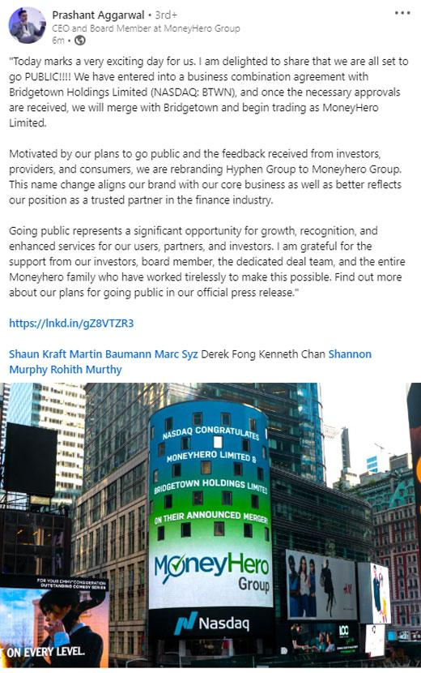

Forward-Looking Statements

This communication includes “forward-looking statements” within the meaning of the United States federal securities laws with respect to the proposed Business Combination and also contains certain financial forecasts and projections. All statements other than statements of historical fact contained in this communication, including, but not limited to, statements as to the listing of MoneyHero Limited (“PubCo”)’s securities and the potential benefits of the consummation of the proposed Business Combination, are forward-looking statements. Some of these forward-looking statements can be identified by the use of forward-looking words, including “outlook,” “believes,” “expects,” “potential,” “continues,” “may,” “will,” “should,” “could,” “seeks,” “predicts,” “intends,” “trends,” “plans,” “estimates,” “anticipates” or the negative version of these words or other comparable words. All forward-looking statements are based upon estimates and forecasts and reflect the views, assumptions, expectations, and opinions of Bridgetown and the Company, which are all subject to change due to various factors including, without limitation, changes in general economic conditions. Any such estimates, assumptions, expectations, forecasts, views or opinions, whether or not identified in this communication, should be regarded as indicative, preliminary and for illustrative purposes only and should not be relied upon as being necessarily indicative of future results.

The forward-looking statements and financial forecasts and projections contained in this communication are subject to a number of factors, risks and uncertainties. Potential risks and uncertainties that could cause the actual results to differ materially from those expressed or implied by forward-looking statements include, but are not limited to, changes in business, market, financial, political and legal conditions; the timing and structure of the Business Combination; changes to the proposed structure of the Business Combination that may be required or appropriate as a result of applicable laws or regulations; the inability of the parties to successfully or timely consummate the Business Combination and the other transactions in connection therewith, including as a result of the risk that any regulatory approvals are not obtained, are delayed or are subject to unanticipated conditions that could adversely affect the combined company or the expected benefits of the Business Combination or that the approval of the shareholders of Bridgetown or the Company is not obtained; the risk that the Business Combination disrupts current plans and operations of Bridgetown or the Company as a result of the announcement and consummation of the Business Combination; PubCo’s inability to obtain or maintain the listing of its securities on Nasdaq following the Business Combination; failure to realize the anticipated benefits of Business Combination; risk relating to the uncertainty of the projected financial information with respect to the Company; the amount of redemption requests made by Bridgetown’s shareholders and the amount of funds available in Bridgetown’s trust account; the Company’s ability to attract new and retain existing customers in a cost effective manner; competitive pressures in and any disruption to the industry in which the Company and its subsidiaries (the “Group”) operate; the Group’s ability to achieve profitability despite a history of losses; and the Group’s ability to implement its growth strategies and manage its growth. You should carefully consider the foregoing factors and the other risks and uncertainties described in the “Risk Factors” section of PubCo’s registration statement on Form F-4 (the “Registration Statement”), the proxy statement/prospectus discussed below, Bridgetown’s periodic reports and other documents to be filed by PubCo or Bridgetown from time to time with the U.S. Securities and Exchange Commission (the “SEC”). These filings identify and address other important risks and uncertainties that could cause actual events and results to differ materially from those contained in the forward-looking statements. In addition, there may be additional risks that neither Bridgetown nor the Company presently knows, or that Bridgetown or the Company currently believes are immaterial, that could also cause actual results to differ from those contained in the forward-looking statements. Forward-looking statements reflect Bridgetown’s and the Company’s expectations, plans, projections or forecasts of future events and view. If any of the risks materialize or Bridgetown’s or the Company’s assumptions prove incorrect, actual results could differ materially from the results implied by these forward-looking statements.

Forward-looking statements speak only as of the date they are made. Bridgetown and the Company anticipate that subsequent events and developments may cause their assessments to change. However, while PubCo, Bridgetown and the Company may elect to update these forward-looking statements at some point in the future, PubCo, Bridgetown and the Company specifically disclaim any obligation to do so, except as required by law. The inclusion of any statement in this document does not constitute an admission by the Company nor Bridgetown or any other person that the events or circumstances described in such statement are material. These forward-looking statements should not be relied upon as representing Bridgetown’s or the Company’s assessments as of any date subsequent to the date of this document. Accordingly, undue reliance should not be placed upon the forward-looking statements. In addition, the analyses of the Company and Bridgetown contained herein are not, and do not purport to be, appraisals of the securities, assets or business of the Company, Bridgetown or any other entity.

Additional Information

This communication relates to the proposed Business Combination between the Company and Bridgetown. This document does not constitute an offer to sell or exchange, or the solicitation of an offer to buy or exchange, any securities, nor shall there be any sale of securities in any jurisdiction in which such offer, sale or exchange would be unlawful prior to registration or qualification under the securities laws of any such jurisdiction. The proposed Business Combination will be submitted to shareholders of Bridgetown for their consideration.

2

PubCo intends to file the Registration Statement with the SEC, which will include a preliminary proxy statement in connection with Bridgetown’s solicitation for proxies for the vote by Bridgetown’s shareholders in connection with the proposed Business Combination and other matters as described in the Registration Statement and a prospectus relating to the offer of the securities to be issued to the Company’s and Bridgetown’s shareholders in connection with the closing of the proposed Business Combination. Bridgetown and PubCo also will file other documents regarding the proposed Business Combination with the SEC.

After the Registration Statement has been filed and declared effective, Bridgetown will mail a definitive proxy statement and other relevant documents to its shareholders as of the record date established for voting on the proposed Business Combination. This communication is not a substitute for the Registration Statement, the definitive proxy statement/prospectus or any other document that Bridgetown will send to its shareholders in connection with the Business Combination. Bridgetown’s shareholders and other interested persons are advised to read, once available, the preliminary proxy statement/prospectus and any amendments thereto and, once available, the definitive proxy statement/prospectus, in connection with Bridgetown’s solicitation of proxies for its extraordinary general meeting of shareholders to be held to approve, among other things, the proposed transactions, because these documents will contain important information about Bridgetown, PubCo, the Company and the proposed Business Combination. Shareholders and investors may also obtain a copy of the preliminary or definitive proxy statement, once available, as well as other documents filed with the SEC regarding the proposed transactions and other documents filed with the SEC by Bridgetown, without charge, at the SEC’s website located at www.sec.gov or by directing a request to Bridgetown. The information contained on, or that may be accessed through, the websites referenced in this document is not incorporated by reference into, and is not a part of, this document.

Participants in the Solicitation

Bridgetown, PubCo and the Company and certain of their respective directors, executive officers and other members of management and employees may, under SEC rules, be deemed to be participants in the solicitations of proxies from Bridgetown’s shareholders in connection with the proposed transactions. Information regarding the persons who may, under SEC rules, be deemed participants in the solicitation of Bridgetown’s shareholders in connection with the proposed transactions will be set forth in PubCo’s proxy statement/prospectus to be filed with the SEC. You can find more information about Bridgetown’s directors and executive officers in Bridgetown’s annual report on Form 10-K for the fiscal year ended December 31, 2022 filed with the SEC on March 30, 2023. Additional information regarding the participants in the proxy solicitation and a description of their direct and indirect interests will be included in the proxy statement/prospectus when it becomes available. Shareholders, potential investors and other interested persons should read the proxy statement/prospectus carefully when it becomes available before making any voting or investment decisions. You may obtain free copies of these documents from the sources indicated above.

No Offer or Solicitation

This communication is for informational purposes only and shall not constitute an offer to sell or the solicitation of an offer to buy any securities pursuant to the proposed Business Combination or otherwise, nor shall there be any sale of securities in any jurisdiction in which the offer, solicitation or sale would be unlawful prior to the registration or qualification under the securities laws of any such jurisdiction. No offer of securities shall be made except by means of a prospectus meeting the requirements of Section 10 of the Securities Act of 1933, as amended.

3

